2. El entorno de desarrollo Java. Arquitectura J2EE.

Java EE Tutorial (Derek Banas):
https://www.youtube.com/watch?v=0dW577tJXkk

Java EE Architecture:
https://www.youtube.com/watch?v=5CVbtcHoVxA

Java EE Interview questions:
https://www.educba.com/java-ee-interview-questions/

J2EE: Java 2 platform, Enterprise Edition

WEB-INF
Ficheros a los que no se debe acceder via web (ficheros de datos, web.xml, clases java, etc..)
https://stackoverflow.com/questions/19786142/what-is-web-inf-used-for-in-a-java-ee-web-application

META-INF
Directorio interno de java, donde almacena las carpetas y ficheros necesarios para funcionar. No se debería (o en muy contadas ocasiones) meter ficheros directamente en este directorio.
https://stackoverflow.com/questions/70216/whats-the-purpose-of-meta-inf

¿Que es un Java Bean?
A JavaBean is just a standard
- All properties private (use getters/setters)
- A public no-argument constructor
- Implements Serializable.
Dependency Injection
https://www.youtube.com/watch?v=IKD2-MAkXyQ

Inversion of Control
https://www.youtube.com/watch?v=EPv9-cHEmQw

Java EE Servers
A Java EE server is a server application that the implements the Java EE platform APIs and provides the standard Java EE services. Java EE servers are sometimes called application servers, because they allow you to serve application data to clients, much like web servers serve web pages to web browsers.
Java EE servers host several application component types that correspond to the tiers in a multi-tiered application. The Java EE server provides services to these components in the form of a container.

Java EE Containers
Java EE containers are the interface between the component and the lower-level functionality provided by the platform to support that component. The functionality of the container is defined by the platform, and is different for each component type. Nonetheless, the server allows the different component types to work together to provide functionality in an enterprise application.
Tomcat is a servlet container, servlets don’t have a main() method so they are under the control of another Java application called a Container.

The Web Container
The web container is the interface between web components and the web server. A web component can be a servlet, a JavaServer Faces Facelets page, or a JSP page. The container manages the component's lifecycle, dispatches requests to application components, and provides interfaces to context data, such as information about the current request.

The Application Client Container
The application client container is the interface between Java EE application clients, which are special Java SE applications that use Java EE server components, and the Java EE server. The application client container runs on the client machine, and is the gateway between the client application and the Java EE server components that the client uses.

The EJB Container
The EJB container is the interface between enterprise beans, which provide the business logic in a Java EE application, and the Java EE server. The EJB container runs on the Java EE server and manages the execution of an application's enterprise beans.
EJB: Enterprise Java Bean
Si no usas Enterprise Edition, EJB -> JB -> POJO (Plain Old Java Object).
JSP: Java Server Page (es una plantilla)
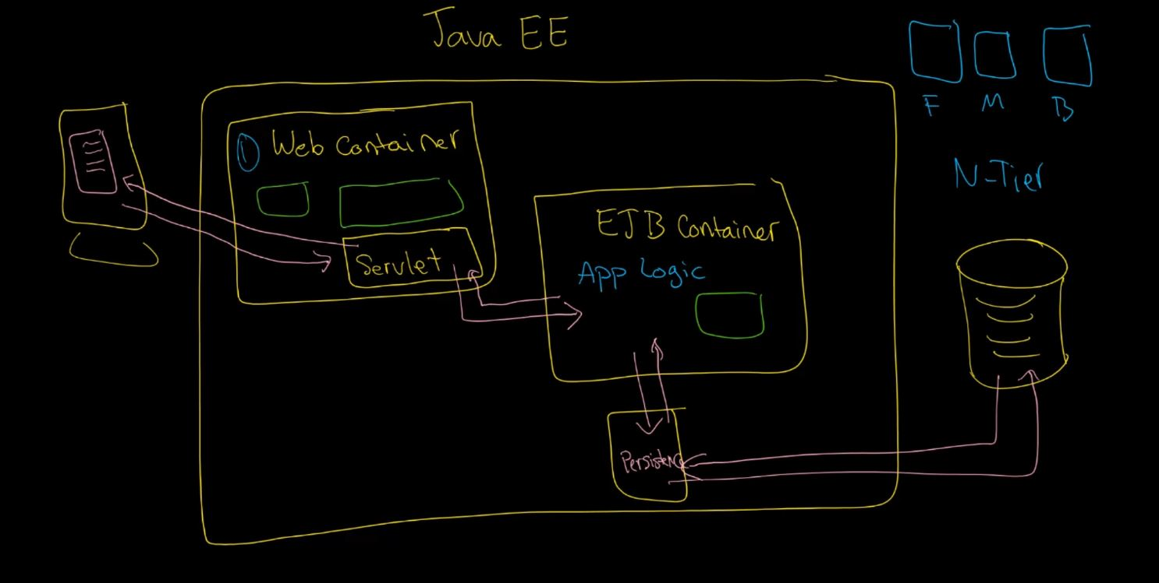

J2EE vs Java EE vs Jakarta EE
In the first version of Java, Java enterprise extensions were simply a part of the core JDK.
Then, as part of Java 2 in 1999, these extensions were broken out of the standard binaries, and J2EE, or Java 2 Platform Enterprise Edition, was born. It would keep that name until 2006.
For Java 5 in 2006, J2EE was renamed to Java EE or Java Platform Enterprise Edition. That name would stick all the way to September 2017, when something major happened.
See, in September 2017, Oracle decided to give away the rights for Java EE to the Eclipse Foundation (the language is still owned by Oracle).
